Page builder + coding knowledge

**Dead element**

href=#

**unordered list**

<ul>

<li>cat nip</li>

<li>laser pointers</li>

<li>lasagna</li>

</ul>

**Ordered list**

<ol>

<li>Garfield</li>

<li>Sylvester</li>

</ol>

**Input type**

<input type="text">

**Input type and placeholder**

<input type="text" placeholder="cat Photo url">

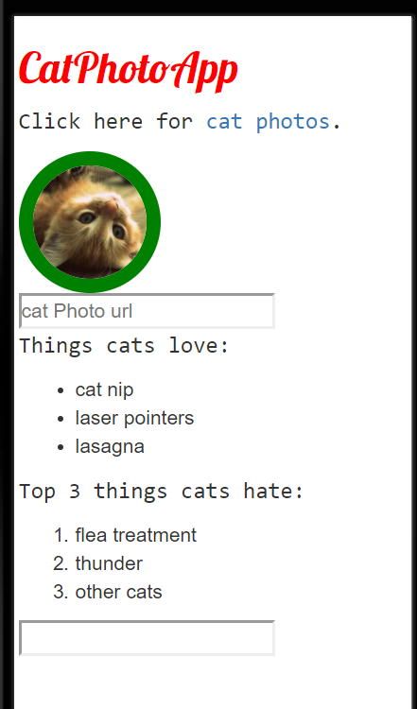

**Create a form element**

You can build web forms that actually submit data to a server using nothing more than pure HTML. You can do this by specifying an action on your form element.

<form action="/submit-cat-photo">

<input type="text" placeholder="cat photo URL">

</form>

Chat bot

**the inevitable**

Game making

PlayMaker

RPGmaker

**Add a submit button to a form (if outside the nested, need JavaScript to submit text)**

<form action="/submit-cat-photo">

<input type="text" placeholder="cat photo URL">

<button type="submit">Submit</button>

</form>

**Use HTML5 to Require a Field**

<form action="/submit-cat-photo">

<input type="text" required placeholder="cat photo URL">

<button type="submit">Submit</button>

</form>

**Create a Set of Radio Buttons**

<label><input type="radio" name="indoor-outdoor">indoor</label>

<label><input type="radio" name="indoor-outdoor">outdoor</label>

**Create a Set of Checkboxes**

<label><input type="checkbox" name="personality"> Grumpy</label>

<label><input type="checkbox" name="personality"> Dopey</label>

<label><input type="checkbox" name="personality"> Happy</label>

**Check Radio Buttons and Checkboxes by Default**

<label><input type="radio" name="indoor-outdoor" checked> Indoor</label>

<label><input type="radio" name="indoor-outdoor"> Outdoor</label>

<label><input type="checkbox" name="personality" checked> Loving</label>

**Nest Many Elements within a Single Div Element**

<div>

<p>Things cats love:</p>

<ul>

<li>cat nip</li>

<li>laser pointers</li>

<li>lasagna</li>

</ul>

<p>Top 3 things cats hate:</p>

<ol>

<li>flea treatment</li>

<li>thunder</li>

<li>other cats</li>

</ol>

</div>

**Give a Background Color to a Div Element**

<style>

.silver-background {

background-color: silver;

}

</style>

<div class="silver-background">

</div>

**Set the ID of an Element**

<form id = cat-photo-form action="/submit-cat-photo">